M02 Chapter 3 Hands On Projects

- HOP 3-1
  - Screenshot of TCP packet with items expanded from steps 9-14
Step 9
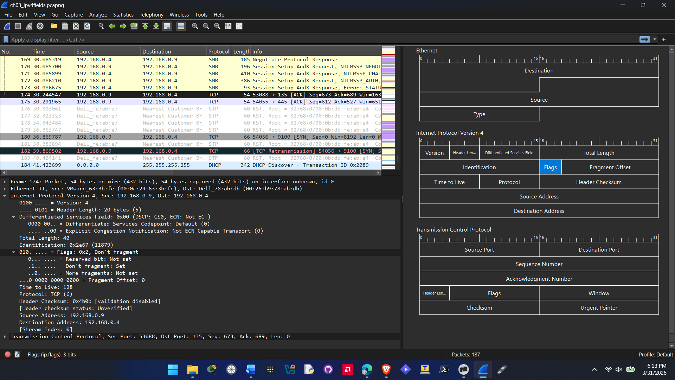
Step 10:
Version is 4 and header length is 20bytes (5)
Step 11:
Total length field value is 40 and Identification field is 0x2e67 (11879)
Step 12:
Fragment offset is 0, Time to live is 128, and Protocol is TCP(6)
Step 13:
Header Checksum field is 0x4b0b [validation disabled]
Step 14:
Source field is 192.168.0.9 and Destination field is 192.168.0.4

- HOP 3-2
  - Screenshot of IPv6 packet with items expanded from steps 10-12
Step 10
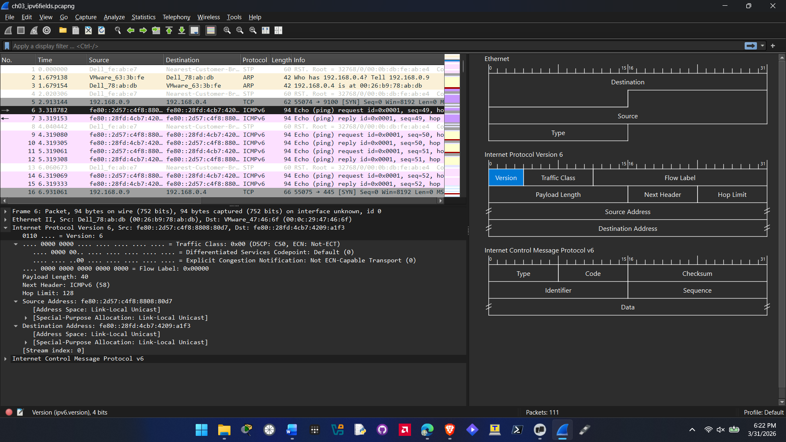
Step 11
The traffic class field has two parts the DSCP and the ECN
Traffic class field value: 0x00 (DSCP: CS0, ECN: Not-ECT)
Differentiated Services Codepoint is set to default (0)
Explicit Congestion Notification is set to not ECN-Capable
Step 12
Payload Length: 40
Next Header: ICMPv6 (58)
Hop Limit: 128
Source Address: fe80::2d57:c4f8:8808:80d7
Destination Address: fe80::28fd:4cb7:4209:a1f3
- HOP 3-3
  - Screenshot of IPv6 packet with items expanded from steps 4-6
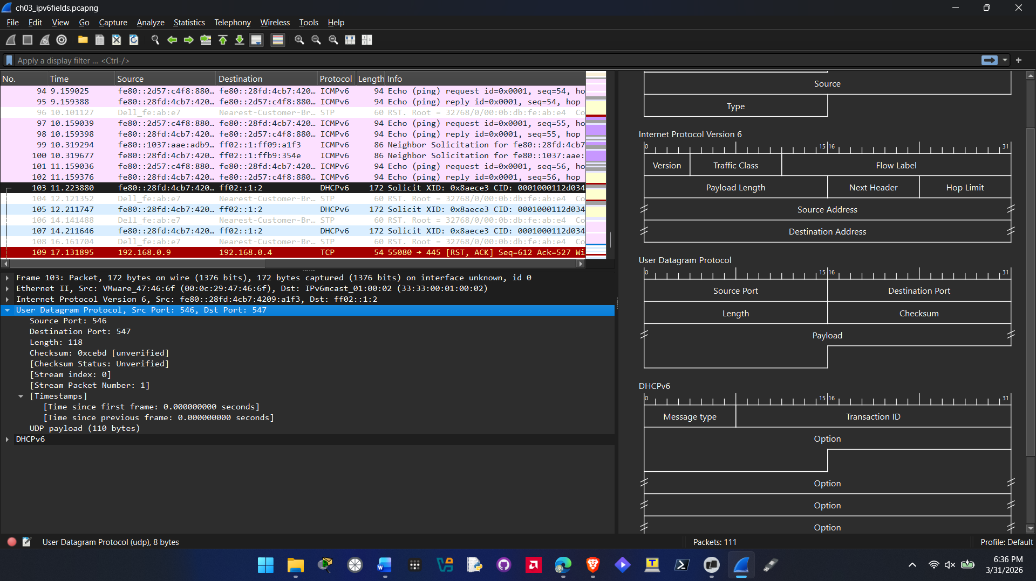
Step 4
Source Port: 546
Destination Port: 547
Length: 118
Step 5
Checksum: 0xcebd [unverified]
Checksum Status: Unverified

